**Pratik Chandrakant Borge CDEC B24**

**Lightstreamer in docker**

**Step 1:- Create an EC2 instance**

**Ports:22, 80**

**Step 2:- Connect to EC2 instance**

**Step 3:- Install Docker Engine latest version**

**<https://docs.docker.com/engine/install/ubuntu/> (for ubuntu)**

**Step 4:- Pull lightstreamer image**

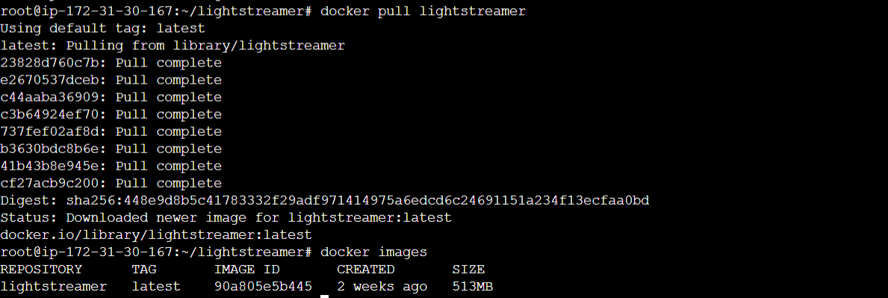

**Step 5:- Create container using Image and log in to create database**

**docker run -d -p 80:8080 <imageID>**

**Step 6:- Copy instanceIP and paste into browser**

